Намерете непозната секвенция в

<http://www.ncbi.nlm.nih.gov>

Организъм

**Chain A, Cannabinoid receptor 1,Flavodoxin,Cannabinoid receptor 1 [Homo sapiens]**

Ген

**Query 1 GENFMDIECFMVLNPSQQLAIAVLSLTLGTFTVLENLLVLCVILHSRSLRCRPSYHFIGS 60**

**GENFMDIECFMVLNPSQQLAIAVLSLTLGTFTVLENLLVLCVILHSRSLRCRPSYHFIGS**

**Sbjct 1 GENFMDIECFMVLNPSQQLAIAVLSLTLGTFTVLENLLVLCVILHSRSLRCRPSYHFIGS 60**

**Query 61 LAVADLLGSVIFVYSFIDFHVFHRKDSRNVFLFKLGGVTASFTASVGSLFLAAIDRYISI 120**

**LAVADLLGSVIFVYSFIDFHVFHRKDSRNVFLFKLGGVTASFTASVGSLFLAAIDRYISI**

**Sbjct 61 LAVADLLGSVIFVYSFIDFHVFHRKDSRNVFLFKLGGVTASFTASVGSLFLAAIDRYISI 120**

**Query 121 HRPLAYKRIVTRPKAVVAFCLMWTIAIVIAVLPLLGWNCEKLQSVCSDIFPHIDKTYLMF 180**

**HRPLAYKRIVTRPKAVVAFCLMWTIAIVIAVLPLLGWNCEKLQSVCSDIFPHIDKTYLMF**

**Sbjct 121 HRPLAYKRIVTRPKAVVAFCLMWTIAIVIAVLPLLGWNCEKLQSVCSDIFPHIDKTYLMF 180**

**Query 181 WIGVVSVLLLFIVYAYMYILWKAHSHAVAKALIVYGSTTGNTEYTAETIARELADAGYEV 240**

**WIGVVSVLLLFIVYAYMYILWKAHSHAVAKALIVYGSTTGNTEYTAETIARELADAGYEV**

**Sbjct 181 WIGVVSVLLLFIVYAYMYILWKAHSHAVAKALIVYGSTTGNTEYTAETIARELADAGYEV 240**

**Query 241 DSRDAASVEAGGLFEGFDLVLLGCSTWGDDSIELQDDFIPLFDSLEETGAQGRKVACFGC 300**

**DSRDAASVEAGGLFEGFDLVLLGCSTWGDDSIELQDDFIPLFDSLEETGAQGRKVACFGC**

**Sbjct 241 DSRDAASVEAGGLFEGFDLVLLGCSTWGDDSIELQDDFIPLFDSLEETGAQGRKVACFGC 300**

**Query 301 GDSSWEYFCGAVDAIEEKLKNLGAEIVQDGLRIDGDPRAARDDIVGWAHDVRGAIPDQAR 360**

**GDSSWEYFCGAVDAIEEKLKNLGAEIVQDGLRIDGDPRAARDDIVGWAHDVRGAIPDQAR**

**Sbjct 301 GDSSWEYFCGAVDAIEEKLKNLGAEIVQDGLRIDGDPRAARDDIVGWAHDVRGAIPDQAR 360**

**Query 361 MDIELAKTLVLILVVLIICWGPLLAIMVYDVFGKMNKLIKTVFAFCSMLCLLNSTVNPII 420**

**MDIELAKTLVLILVVLIICWGPLLAIMVYDVFGKMNKLIKTVFAFCSMLCLLNSTVNPII**

**Sbjct 361 MDIELAKTLVLILVVLIICWGPLLAIMVYDVFGKMNKLIKTVFAFCSMLCLLNSTVNPII 420**

**Query 421 YALRSKDLRHAFRSMFPS 438**

**YALRSKDLRHAFRSMFPS**

**Sbjct 421 YALRSKDLRHAFRSMFPS 438**

Протеин

**pdb: molecule 5XR8, chain 65**

<http://www.expasy.org/>

<http://www.uniprot.org>

Организъм

**P21554 Cannabinoid receptor 1 (Homo sapiens)**

Ген

**CNR1**

Протеин

**Cannabinoid receptor 1**

<http://www.ebi.ac.uk>

Анализ на мотиви и домейни

<https://prosite.expasy.org/scanprosite/>

|  |
| --- |
| **hits by profiles:** [2 hits (by 2 distinct profiles) on 1 sequence] |

Upper case represents match positions, lower case insert positions, and the '-' symbol represents deletions relative to the matching profile.

|  |  |
| --- | --- |
| ruler: | https://prosite.expasy.org/cgi-bin/prosite/RulerImage.cgi?hscale=0.6&length=1000 |

|  |  |  |
| --- | --- | --- |
| USERSEQ1 | USERSEQ1 hits | (438 aa) |

<https://www.genome.jp/tools/motif/>

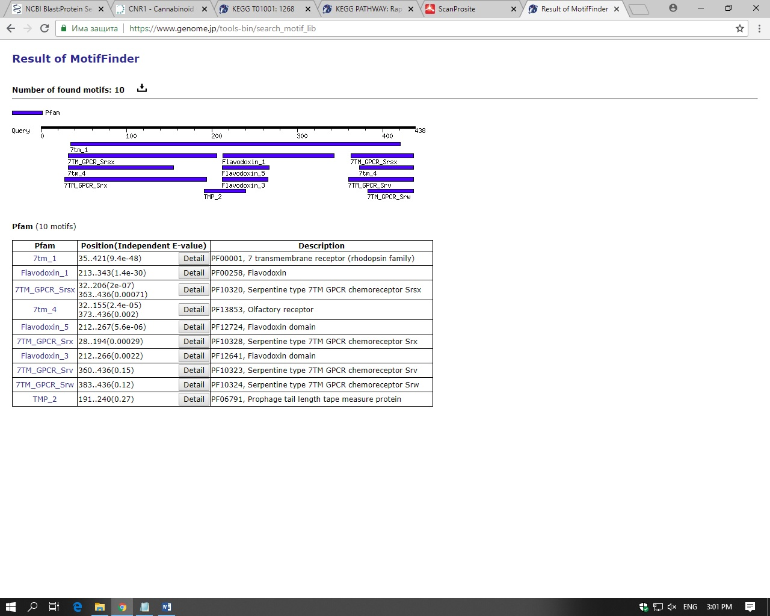

<https://www.ncbi.nlm.nih.gov/guide/domains-structures/>

Участие в метаболитни пътища

<https://www.genome.jp/kegg/pathway.html>

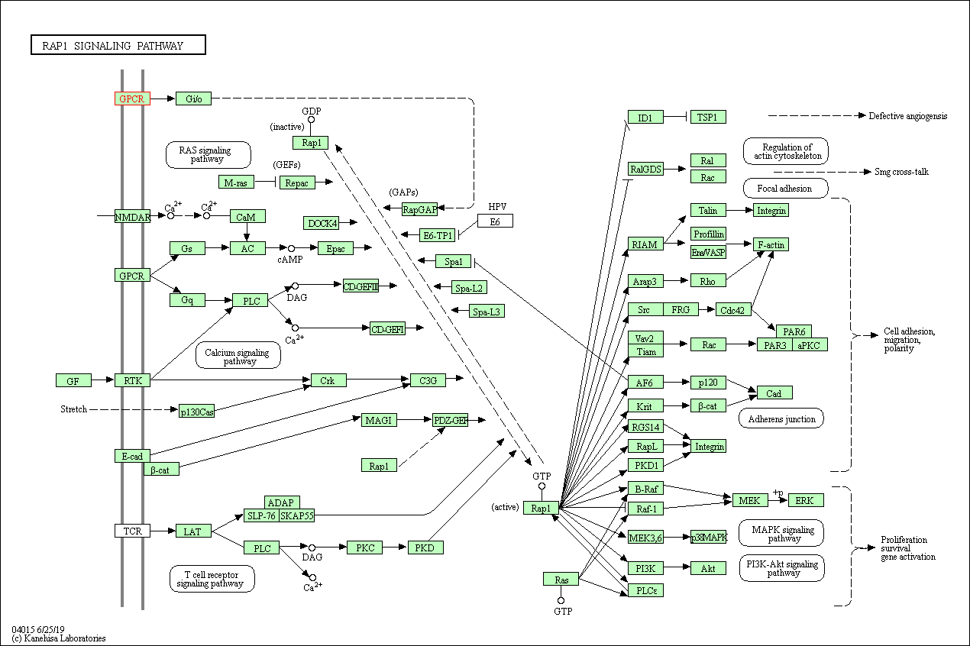

Структура на белтъка 3D View

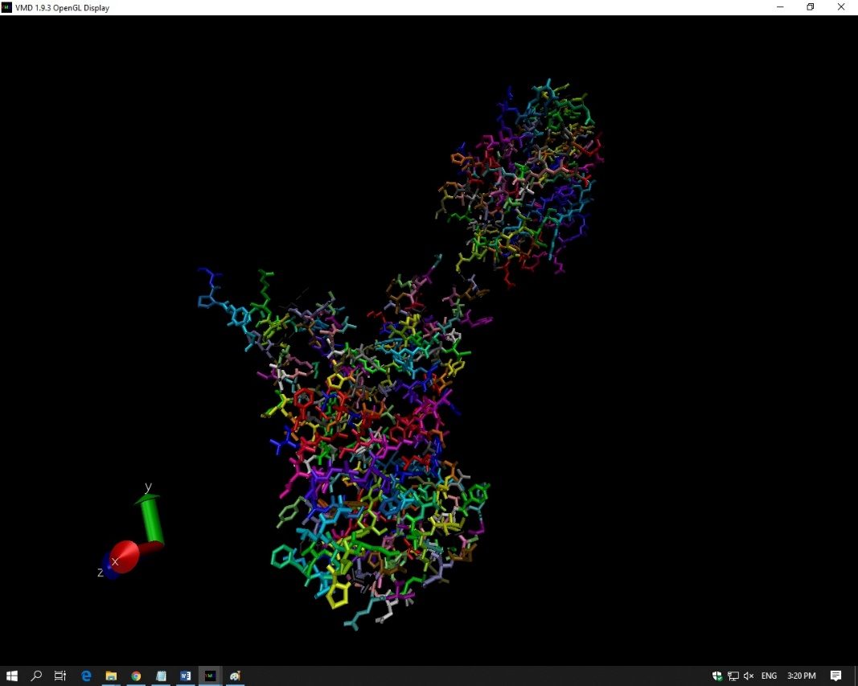

Визуализация с VMD графика и ramachandran plot

